**Using the Logisim Single-Cycle Datapath**

Meant to be a replica of the single-cycle datapath described in the Computer Organization and Design: The Hardware/Software Interface, 5th edition book (ISBN-10: 0124077269).

**Logisim Diagram:**

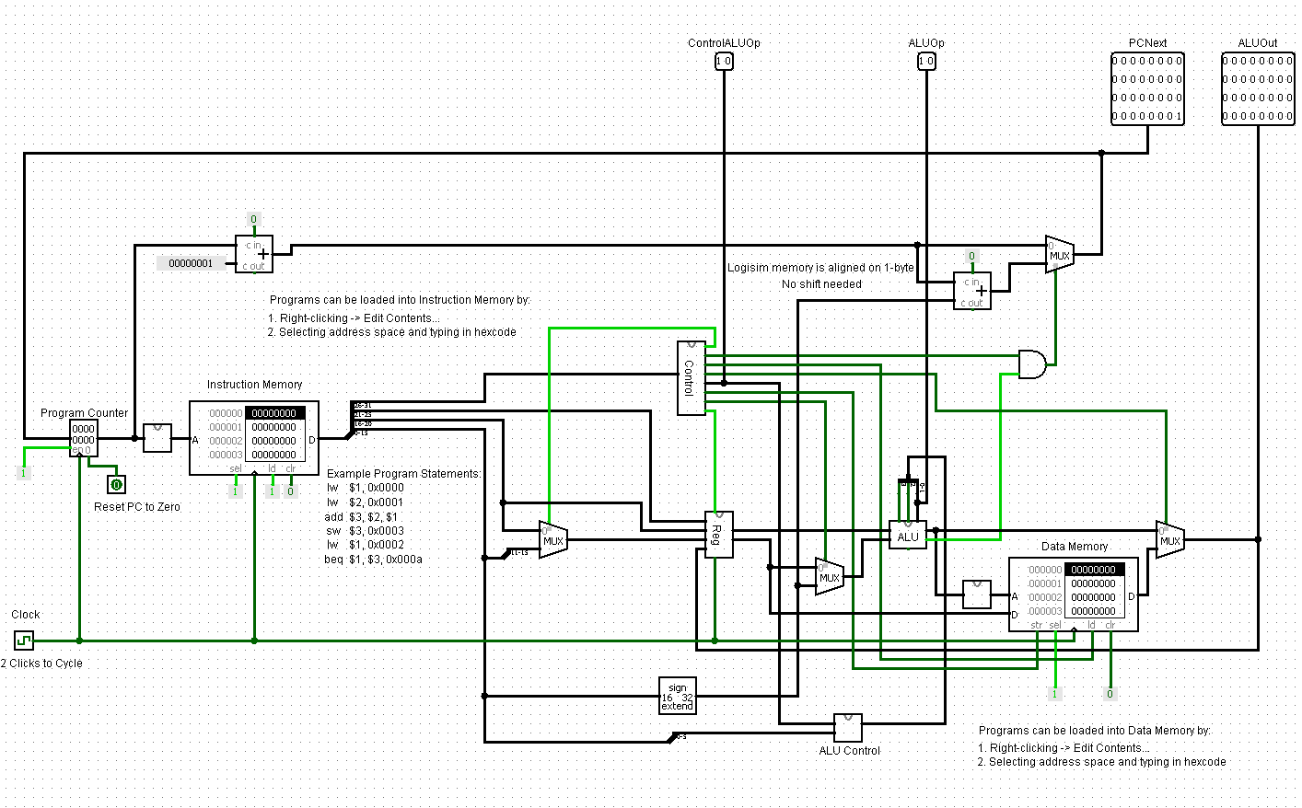

**Book Diagram:** 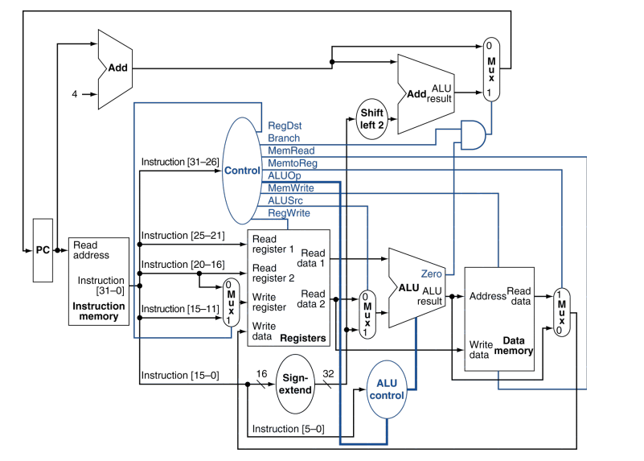

**Logisim Diagram with Labels on Added Components:**

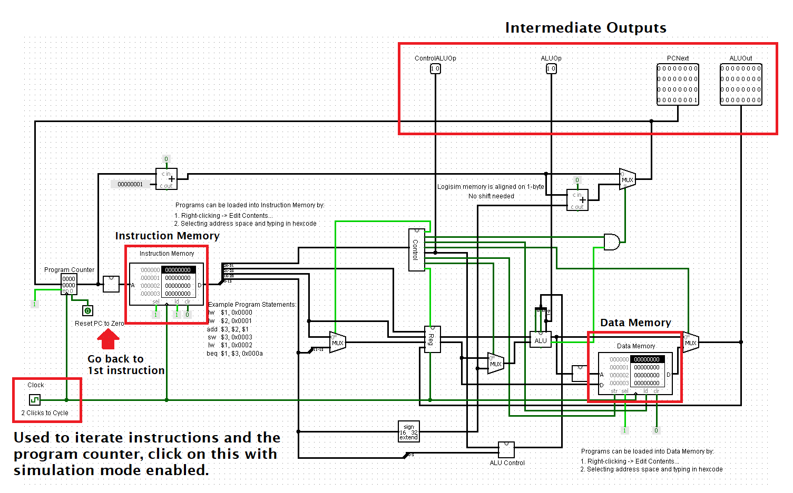

**How to Load and Run the Example Program in Logisim:**

1. Make sure you have the following:
   1. Logisim Executable (<https://sourceforge.net/projects/circuit/>)
   2. Single-Cycle Datapath Logisim File ([link](https://github.com/TaargusTaargus/Single-Cycle-Datapath-Logisim/blob/main/Single-Cycle%20Datapath.circ))
   3. Data Files:
      1. Example Program [Instruction Memory] ([link](https://github.com/TaargusTaargus/Single-Cycle-Datapath-Logisim/blob/main/Example%20Program%20%5BInstruction%20Memory%5D))
      2. Example Data [Data Memory] ([link](https://github.com/TaargusTaargus/Single-Cycle-Datapath-Logisim/blob/main/Example%20Data%20%5BData%20Memory%5D))
2. Open Logisim.
3. Load the Single-Cycle Datapath Logisim File
   1. File -> Open…
4. Load the Example Program and Example Data files into each memory unit:
   1. Right click on Memory Unit -> Load image…
   2. To add your own commands:
      1. Right Click -> Edit contents…
      2. Select the instruction word and enter code in hex
5. Ensure that Simulation Enabled is activated:
   1. Simulate -> Check on Simulation Enabled
6. Select the ‘Change values within circuit’ button (Ctrl+1)



1. To cycle the datapath, click the clock unit in the bottom left.